Hi! Welcome to the instruction manual for my Vermonter's Think Different (TD) Tracker™.

In the Tracker, you'll see three tabs: Mainframe, Answers, and Scoresheet. Most of what you touch will be in the Mainframe tab. You will input players' responses here.

Any questions or suggestions for improvements, please let me know.

Keith (Vermonter)

Table of Contents
Setting up the game 2
Entering players' responses 4
Updating the participant list on JBoard 7
Revealing who responded what 8
Updating the standings 11

Setting up the game

Flip over to the Answers tab. This is where you'll put the correct answers; the Tracker will compare the players' responses with these correct answers, and tabulate them accordingly.
Before you add the correct answers, you'll need to change the values for wrong answers (black and yellow cells). Here are a few examples for the formula you'd put in the first of these, B23. If a wrong answer is worth…

…twice the sheep:
=B25*2
…half the number of players:
=(1/2)*PLAYERS
…the sheep plus 1/4 the number of players: =B25+(1/4)*PLAYERS
B25 is the cell that calculates the Sheep value for the question; typing the word PLAYERS will automatically pull in the number of players in the game. (You don't need to do anything additional to make this happen.)

When you're done, copy and paste the contents of this cell to each of the other black cells.
If you want to add any special rules, add those with the accompanying point values, and paste them below each of the other questions.

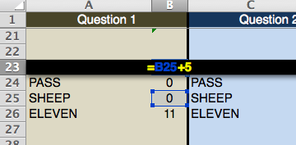
A wrong answer is worth the SHEEP + 5 points; I also added an option called ELEVEN that automatically gives a player 11 points, should he so desire.

Place the correct responses in the appropriate column on the Answers tab. Do not touch the second column of each, as these are set up to automatically calculate scores. Each of these numbers will start off at zero, because you don't have any responses yet!

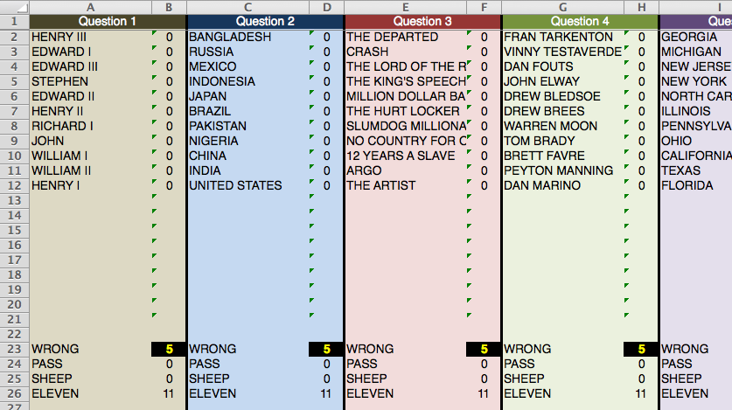
If your questions have more than 20 responses, you should insert new rows somewhere in the middle. You'll need to copy the formula in the second column (B, D, F, etc.) to each new row you create.

Entering players' responses

NOTE: I prefer to set up a Google Form to collect responses. It's easier for everyone: particularly for you. See the Appendix for more information.

Place the players' answers in the Mainframe tab.

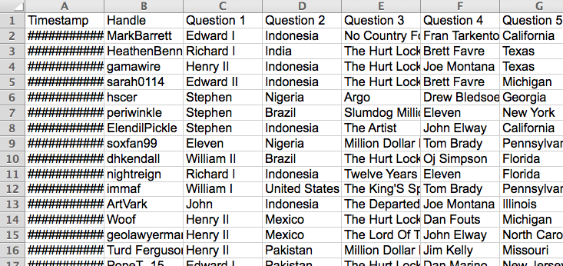

You should see the answers pop over to the Scoresheet tab, and numbers will automatically tabulate.

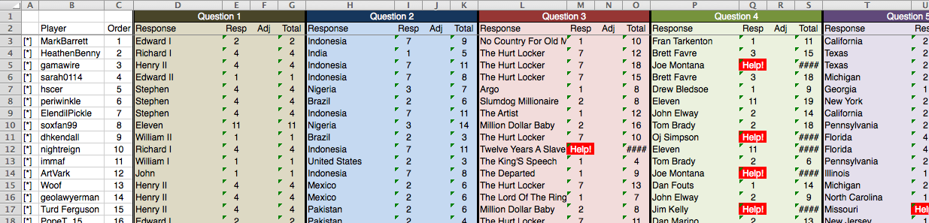

Well, almost all of them, anyway. Do you see those red cells? They say "Help!" and they require your attention.

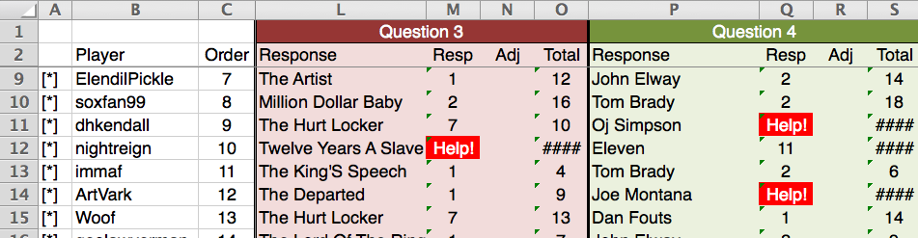

There are two reasons a cell will turn red. For one, maybe a player's response doesn't match exactly the list of answers you placed in the Answers tab. nightreign should receive credit for Twelve Years a Slave; the Answers tab uses the number 12 instead of spelling it out.

If it's correct, manually enter the proper term in the cell.

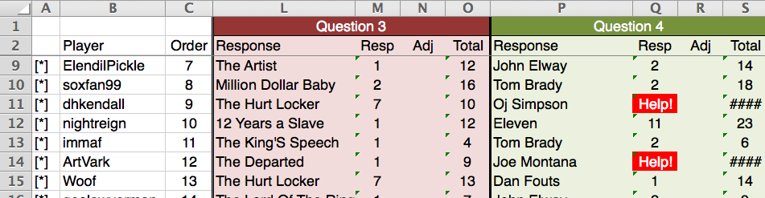
If the response is incorrect, where "Help!" is shown, type XX. This will turn the cell black and apply the "WRONG" score from the Answers tab.

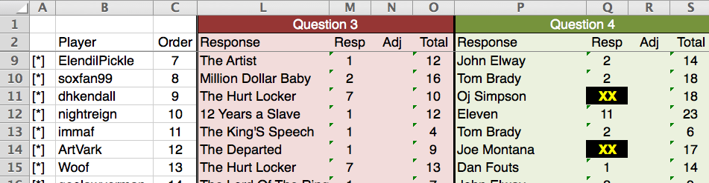
Sorry, guys – nice try!

In either case, the Totals will change from #### to an actual number.

You can use the "Adj" column to add or subtract points for things like bonus questions. It is blank by default.

If you want to get a sense of answers' popularity, flip back to the Answers tab. You can also check to ensure your formulas are working properly.

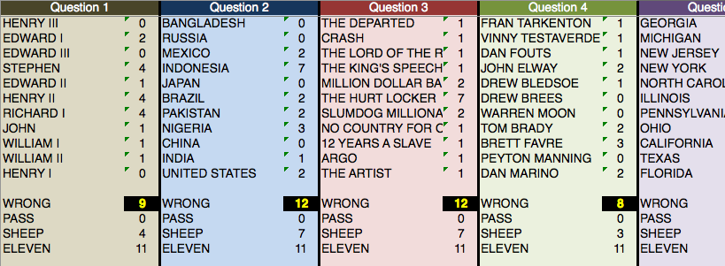
Remember: in this example a wrong answer should be worth the SHEEP value plus 5 points. Everything seems to be working.

Updating the participant list on JBoard

I use the [list] function. If you put [list=1] in BBCode, it will give you a numbered list, with each item marked with [*]. You can just copy and paste this over from the first two columns on Scoresheet.

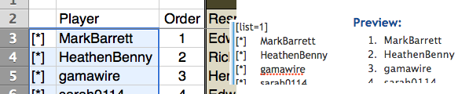

Be sure to end it with [/list].

Revealing who responded what

The calculator now allows you to compile answers for easy copying to JBoard. For the given question:

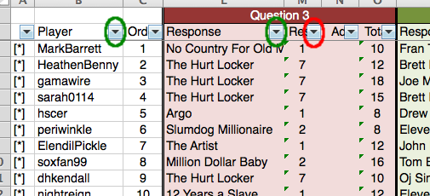

- Sort "Player" ascending (to alphabetize names)
- Sort "Response" ascending (to alphabetize responses)
- Sort "Resp" descending (to put higher-scoring answers first)

It should look something like this when you're done.

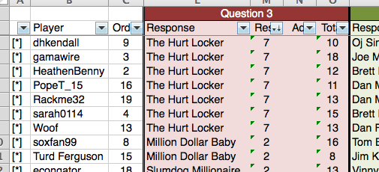

Now, scroll all the way to the right. You will see three gray columns and a green box labeled Question #.

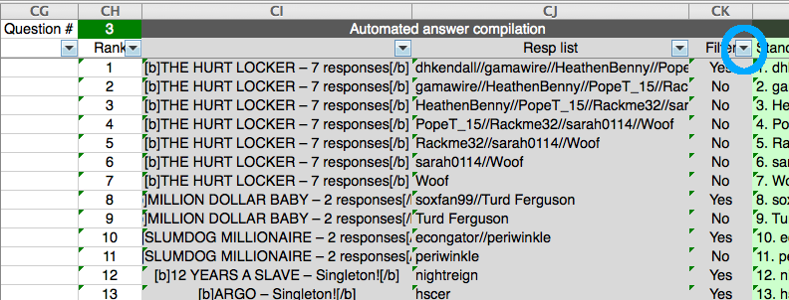

Put the question number in the green box, then filter the third gray column (Filter) so that only "Yes" shows up. Then select the filtered cells in the first two columns and copy them.

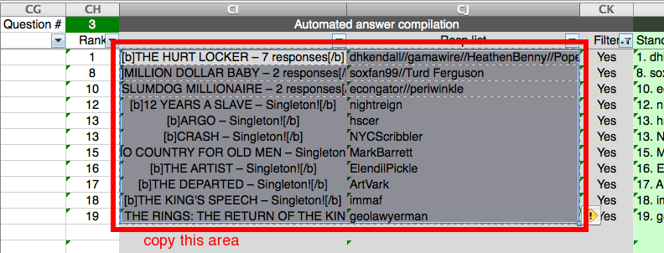

Open a new Microsoft Word document, and paste the data as raw text by going to Edit > Paste Special > Unformatted Text. The text will show up as a giant mass.

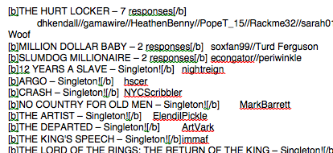

To format it properly, do the following Find & Replace functions in order. (N.B. ^p represents paragraph, ^t represents tab.)

Find | Replace
^p | ^p^p
^t | ^p
// | ^p

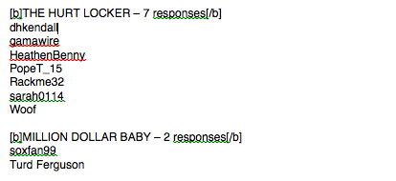

Now the text is ready to be copied to JBoard. You'll need to add unused responses manually. Note that if you like putting incorrect answers at the bottom, you'll need to do that manually, as well.

Updating the standings

To the right of the gray cells is the Automated standings column, in light green.

After you remove the filter for your reveal, sort by Total of your question, and copy the text in green to JBoard.

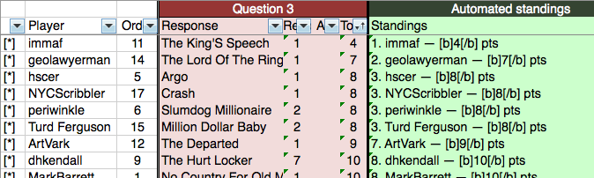

Appendix: setting up a Google Form

To create a Google Form, go to your Google Drive (if you don't have one, it's easy to set up) and create a new Form from the menu at upper left.

Create a field for the player's name as well as for each response, then find the link to the form by going to Share Form at upper right. You can paste this into your JBoard post.

When players submit their responses, they will go into a Google Spreadsheet, which you can access from your Google Drive. Note: You might have to realign the columns in the spreadsheet so that they align with the columns in the Tracker.

For some reason, Google Forms doesn't allow players to see their responses once they've submitted them. You can send them a message with their answers after you add it to the sheet, or do it on request, as you see fit.

