Hi! Thank you for testing out the next generation of my Think Different (TD) Tracker.

The main feature of Version 2.0 is a macro that compiles the results for each question. It eliminates much of the busywork the previous version required.

Note: Except in the one indicated circumstance, do not insert or delete any columns or rows, or the macro might fail.

If you have any questions or suggestions, please let me know.

Keith (Vermonter)

Table of Contents
Version history 1
Setting up the game 2
Updating the participant list on JBoard 6
Revealing who responded what 7
Appendix A: compiling results manually 9
Appendix B: compiling standings manually 11

Version history

1.2 – added ranking changes
2.0 – rebuilt with macro for compiling scores

Setting up the game

Flip over to the Answers tab. This is where you'll put the correct answers; the Tracker will compare the players' responses with these correct answers, and tabulate them accordingly.

Each question has four columns. The first three are for you to provide.

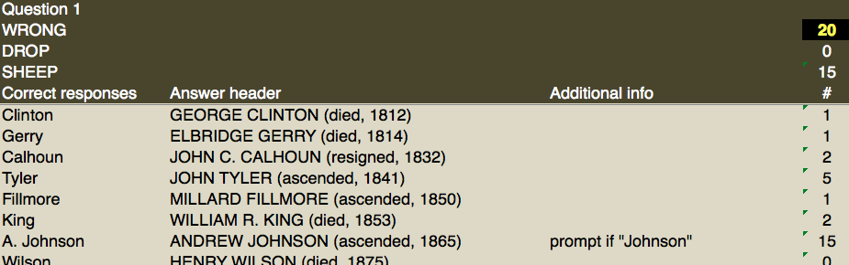

Correct responses: the Tracker will look for these responses in the Scoresheet tab. Pick something easy for you to type, as you'll probably need to adjust a few players' answers to align with what you put here.
Answer header: this text will appear as the header once you reveal the answers on JBoard. Example:
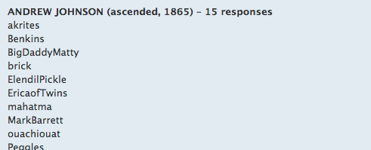

Additional info: anything you want to remember relating to the particular answer. This won't be copied to JBoard.
#: the number of players who selected this answer; automatically calculated.

You'll need to change the values for wrong answers (black and yellow cells). Here are a few examples for the formula you'd put in the first of these, D2. If a wrong answer is worth…

…twice the sheep:
=D4*2
…half the number of players:
=(1/2)*PLAYERS
…the sheep plus 1/4 the number of players: =D4+(1/4)*PLAYERS
D4 is the cell that calculates the Sheep value for the first question; typing the word PLAYERS will automatically pull in the number of players in the game. (You don't need to do anything additional to make this happen.)

Here, WRONG is worth SHEEP + 5:
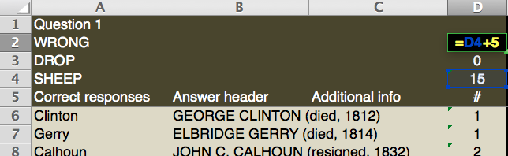

When you're done, copy and paste the contents of this cell to each of the other black cells.

Place the correct responses in the appropriate column on the Answers tab. Do not touch the "#" column of each, as these are set up to automatically calculate scores. Each of these numbers will start off at zero, because you don't have any responses yet!
Entering players' responses

It's easiest to set up a Google Form to take in the responses, then copy them into Mainframe as they come in.

To do this, go to your Google Drive (if you don't have one, it's easy to set up) and create a new Form. Create a field for the player's name as well as for each response.

When players submit their responses, they will go into a Google Spreadsheet, which you can access from your Google Drive. You might have to realign the columns in the spreadsheet so that they align with the columns in the Tracker.

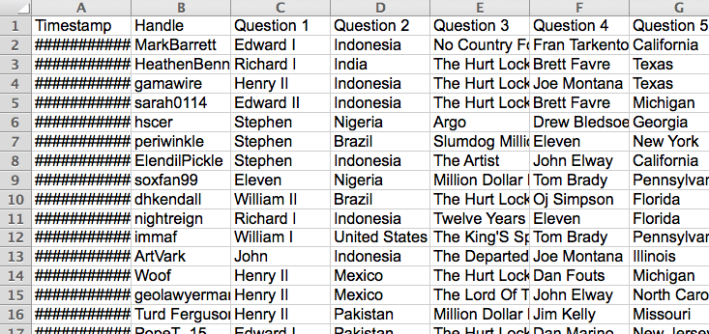

When you copy the responses to the Tracker, they'll be reflected on the Scoresheet tab. The numbers will update automatically.

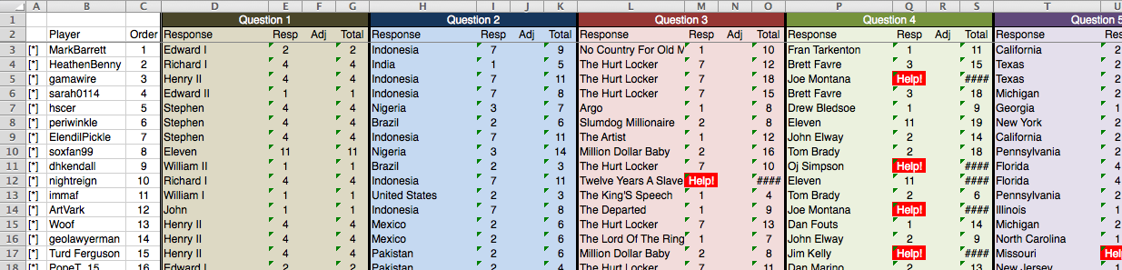

Well, almost all of them, anyway. Do you see those red cells? They say "Help!" and they require your attention.

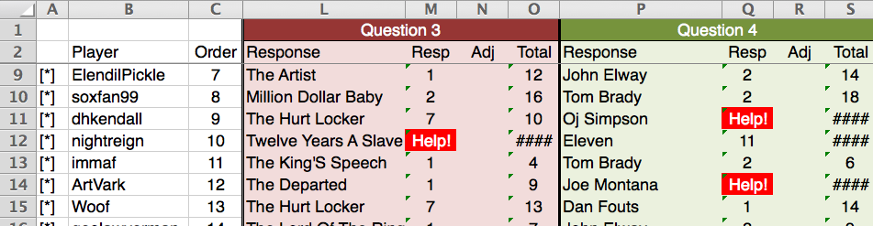

There are two reasons a cell will turn red. For one, maybe a player's response doesn't match exactly the list of answers you placed in the Answers tab. nightreign should receive credit for Twelve Years a Slave; the Answers tab uses the number 12 instead of spelling it out.

If it's correct, manually enter the proper term in the cell.

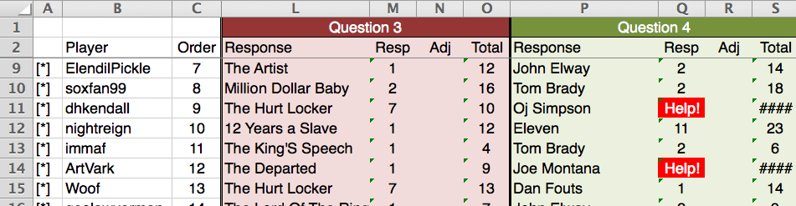
If the response is incorrect, where "Help!" is shown, type XX. This will turn the cell black and apply the "WRONG" score from the Answers tab.

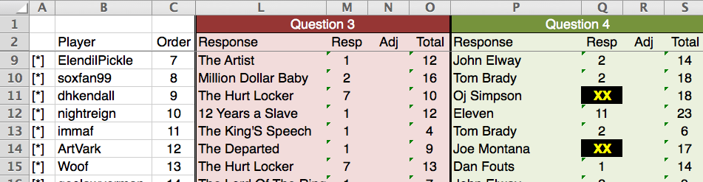
Sorry, guys – nice try!

In either case, the Totals will change from #### to an actual number.

You can use the "Adj" column to add or subtract points for things like bonus questions. It is blank by default.

If you want to get a sense of answers' popularity, flip back to the Answers tab. You can also check to ensure your formulas are working properly.

Updating the participant list on JBoard

I use the [list] function. If you put [list=1] in BBCode, it will give you a numbered list, with each item marked with [*]. You can just copy and paste this over from the first two columns on Scoresheet.

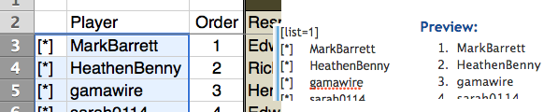

Be sure to end it with [/list].

Revealing who responded what

Once the deadline is closed, it's time for the big reveal!

Start by deleting any unused lines in the Scoresheet tab. (Maybe someday a TD will get up to 128 players!)

This is the only time you should delete any rows or columns.

Place the question number in the box at top left in Scoresheet, then click the button "Run results for Q:". A box will pop up to verify you're running the macro on the right question.

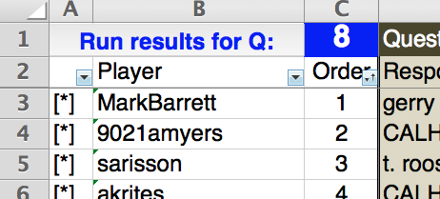

When the macro is done, it will leave you on the Results tab with the proper cells highlighted for results (in columns A and B). Copy this.

Open a new Microsoft Word document, and paste the data as raw text by going to Edit > Paste Special > Unformatted Text. The text will show up as a giant mass.

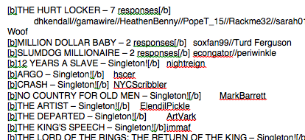

To format it properly, do the following Find & Replace functions in order. (N.B. ^p represents paragraph, ^t represents tab.)

Find | Replace
^p | ^p^p
^t | ^p
// | ^p

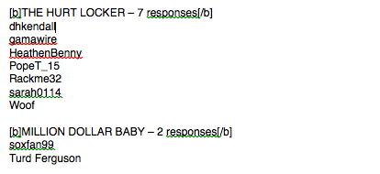

Now the text is ready to be copied to JBoard. You'll need to add unused responses manually. Note that if you like putting incorrect answers at the bottom, you'll need to do that manually, as well.

You can then copy the standings from the Results tab and paste them on JBoard. You should not need to do anything special here.

Appendix A: compiling results manually

Assuming the macro works as designed, you shouldn't have to do any of this. Hooray!

The calculator now allows you to compile answers for easy copying to JBoard. For the given question:

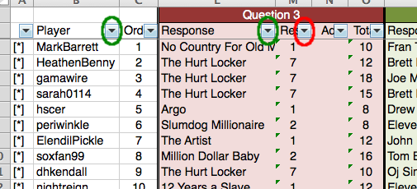

- Sort "Player" ascending (to alphabetize names)
- Sort "Response" ascending (to alphabetize responses)
- Sort "Resp" descending (to put higher-scoring answers first)

It should look something like this when you're done.

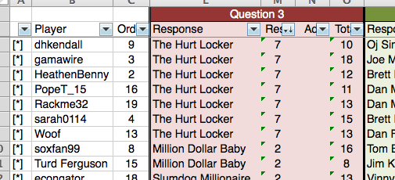

Now, scroll all the way to the right. You will see three gray columns and a green box labeled Question #.

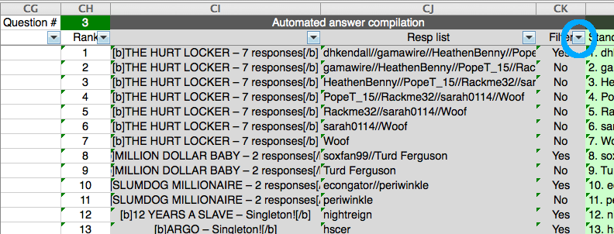

Put the question number in the green box, then filter the third gray column (Filter) so that only "Yes" shows up. Then select the filtered cells in the first two columns and copy them.

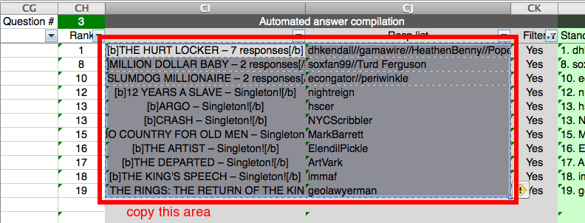

Appendix B: compiling standings manually

You shouldn't have to do any of this, either. Double hooray!

To the right of the gray cells is the Automated standings column, in light green.

After you remove the filter for your reveal, sort by Total of your question, and copy the text in green to JBoard.

